AWS Task 4
Launch an EC2 instance (Linux and Windows) along with a web server. Then, create an EBS volume of 5 GB, attach it to an EC2 machine (Linux and Windows), and take a snapshot. Finally, create an EBS volume using the taken snapshot.

*Created a new Ec2 instance naming Task 4 and connected the instance and then installed the apache2 and the status was running and was able to see the apache webpage in the browser when opened from the instance public IP address
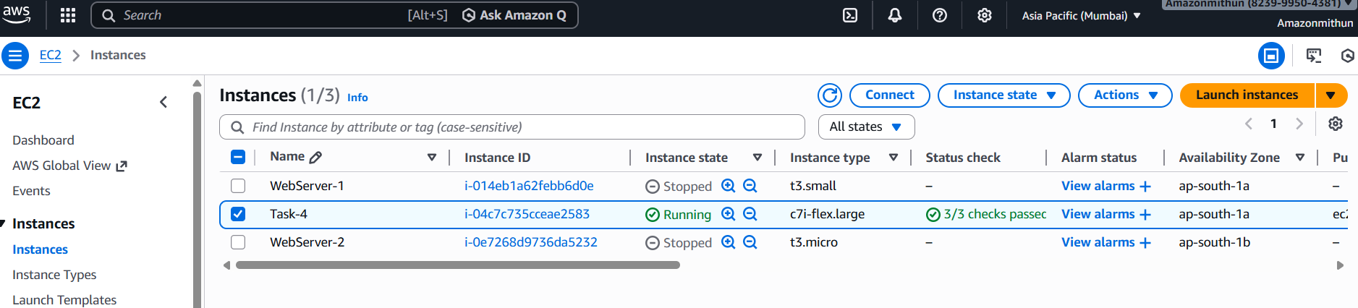
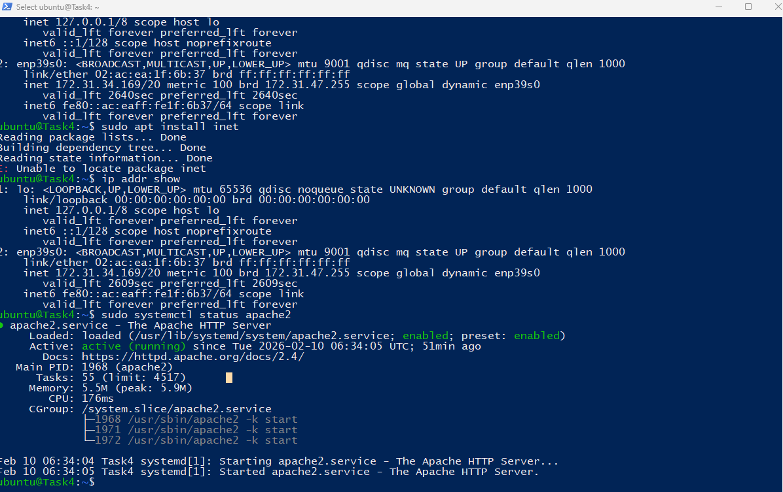
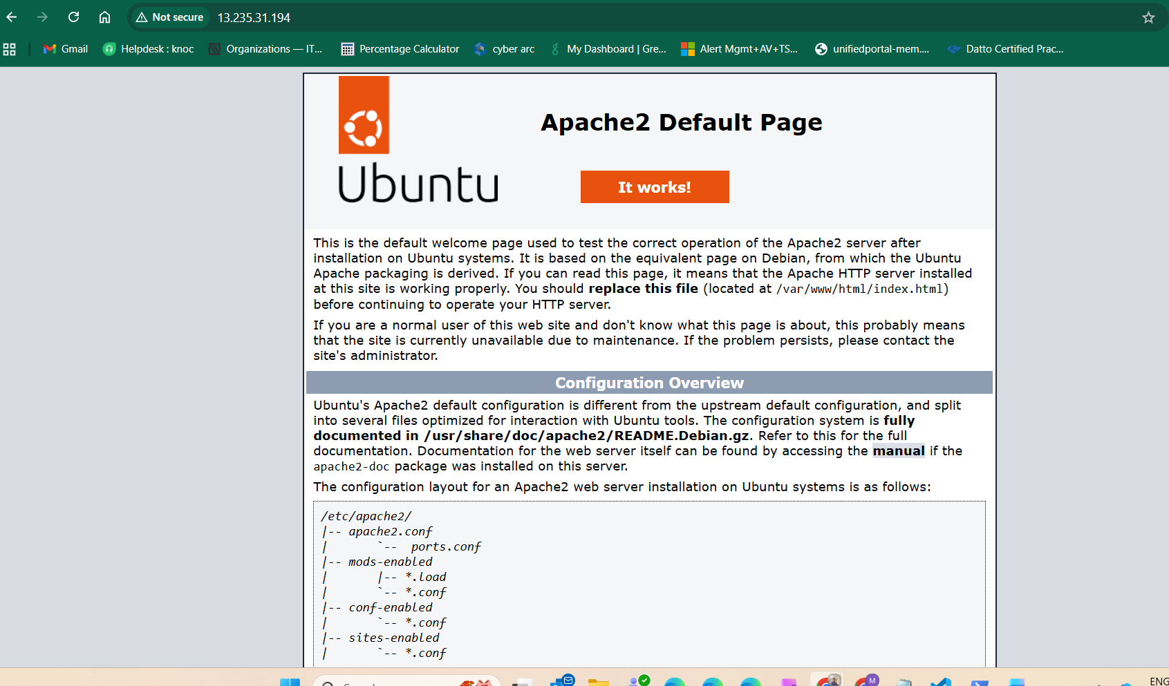
- Also created a windows server instance and installed IIS web server from the roles and features and after the installation tried copying the public ip and pasted in the browser and then able to see the IIS Welcome page

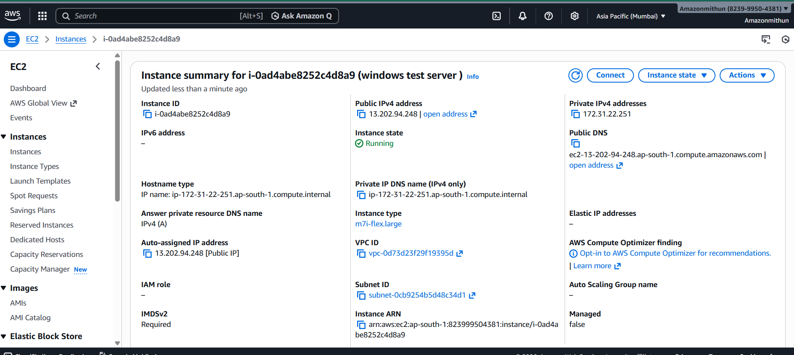

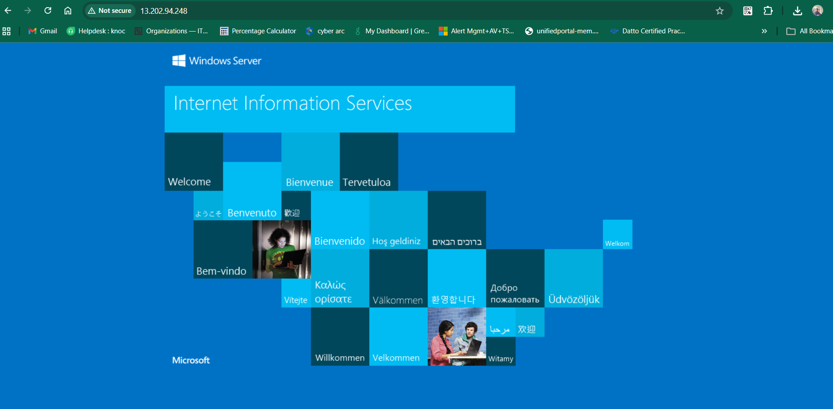
*Created a new Volume for the space GB and matched the volume with the created EC2 instance availability zone and attached the volume to the Ec2 instance
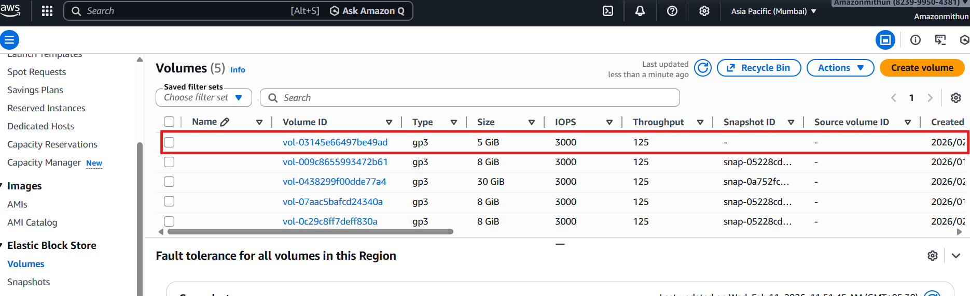
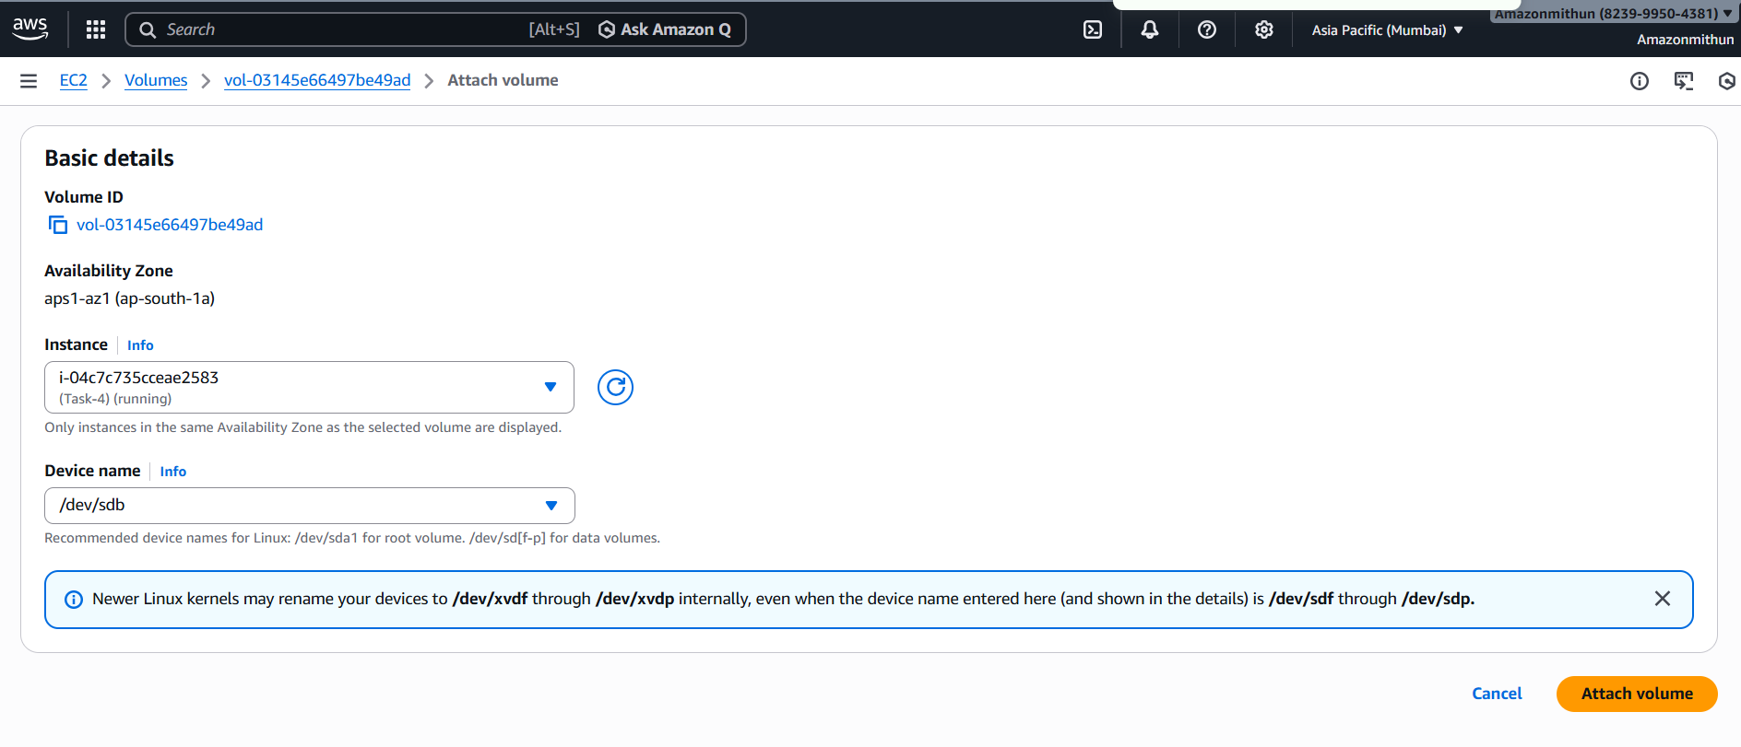
After adding the volume started the task 4 linux EC2 and mounted the volume to data directory
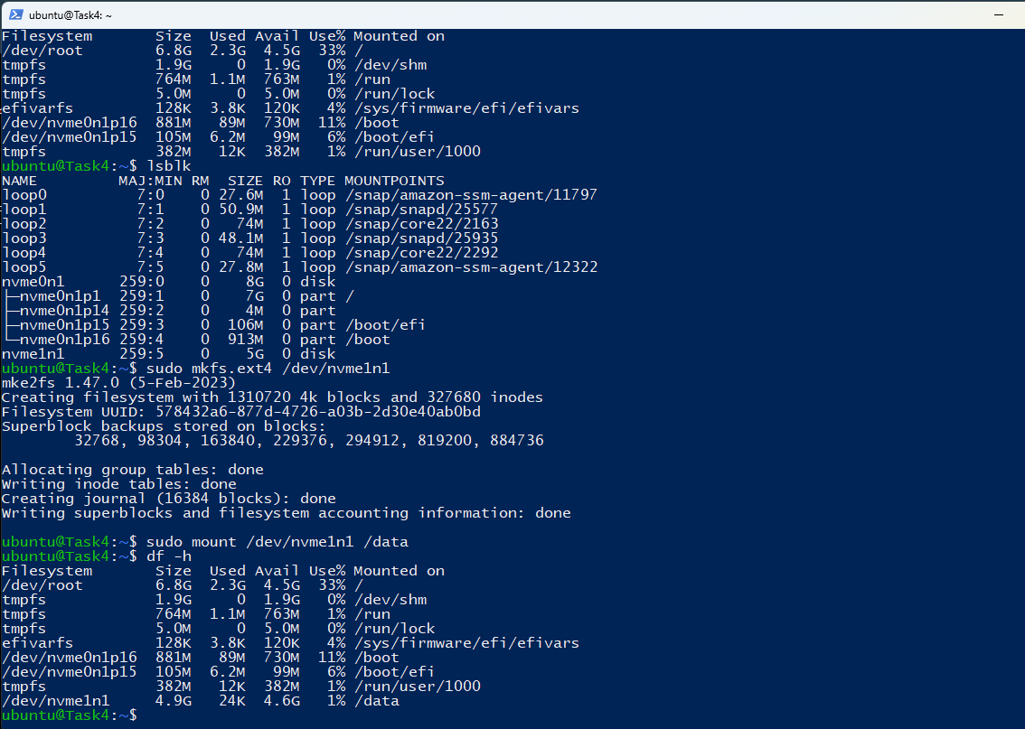
*Created a another volume for the windows server and attached to EC2 instance
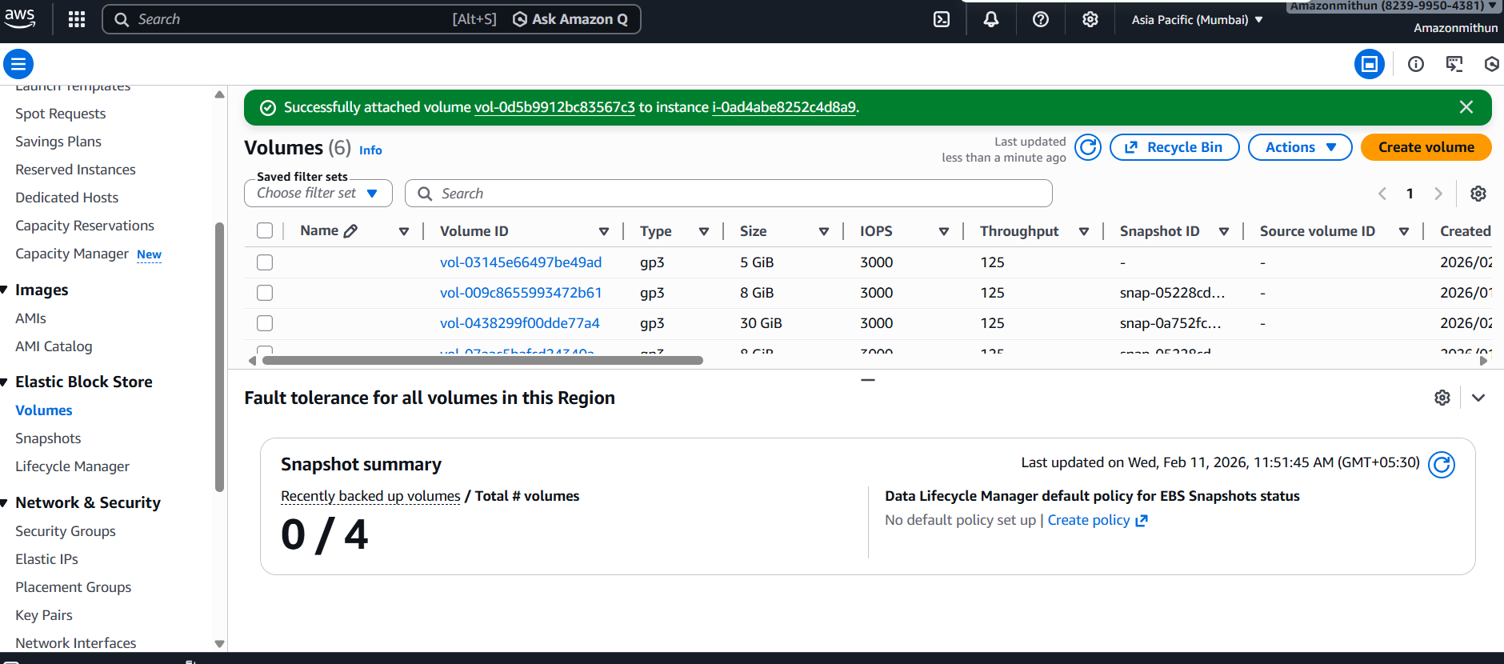
After creating the volume for the windows server made the changes in the Disk management and added the new volume and able to see the drive in the file explorer.
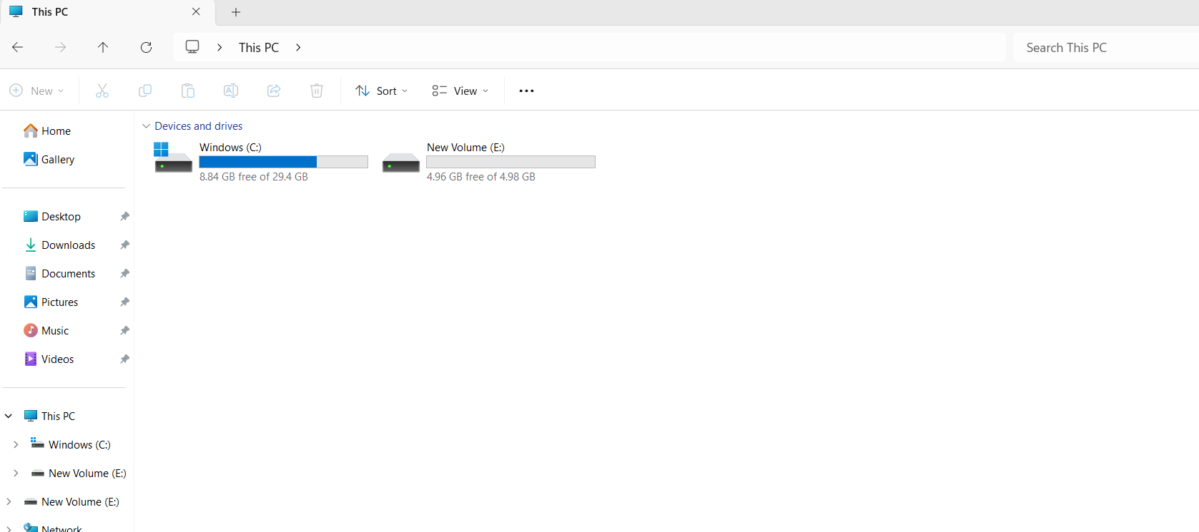
- Took a Snapshot of the volume lor the linux and crated a new volume and attached the volume as backup
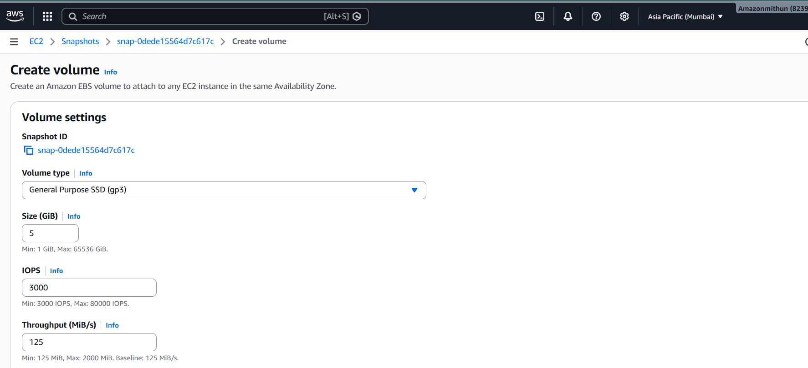
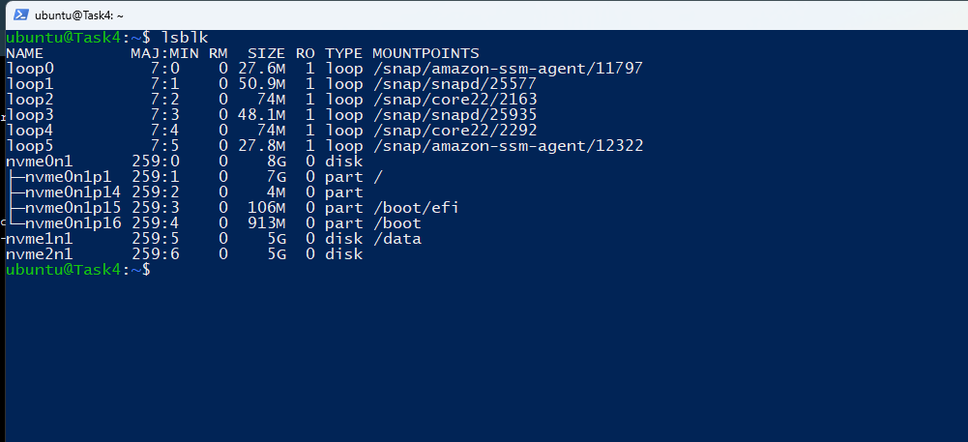

Verification checklist
- Linus Apache running
- Windows IIS Running
- 5 GB EBS attached for both linux and windows
- Volume mount initialized and snapshot created
- Also new volume created from the snapshot and added the volume.

